Data Validation Report – Bank Churn Dataset
Data Engineer: Proud Ndlovu
Tools: Power BI, PostgreSQL
Objective:
To validate the integrity and accuracy of the Power BI dashboard for the bank churn dataset by comparing each KPI against SQL query results.
Process:
For every KPI represented on the dashboard, an SQL query was generated to verify the dashboard visuals. The results were cross-checked to ensure consistency and reliability.

1.Total Customers : SQL results matched Power bi Dashboard ✅


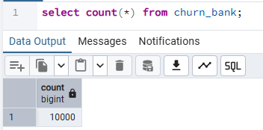
2.Total Churned Customers :SQL results matched POWERBI DASHBOARD ✅


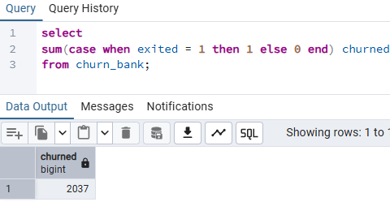
3) Churn Rate : sql results matched the Powerbi dashboard ✅
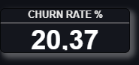
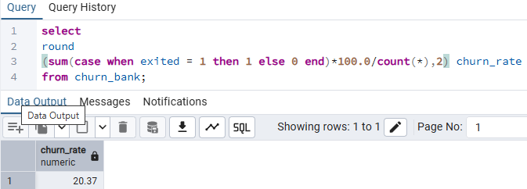
3)TOTAL HIGH RISK CLIENTS: SQL RESULTS MATCHED POWERBI DASHBOARD ✅

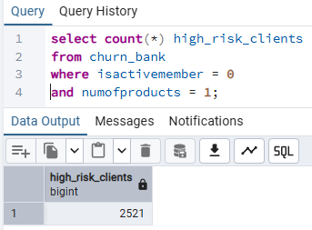

4) CHURN CONTRIBUTION BY COUNTRY : SQL RESULTS MATCHED POWERBI DASHBOARD ✅
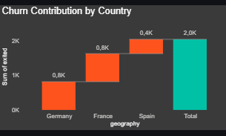
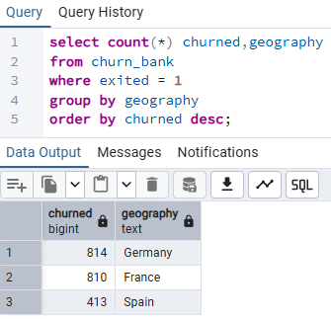

5) ACTIVE MEMBER VS CHURN ANALYSIS : SQL RESULTS MATCHED POWERBI DASHBOARD ✅
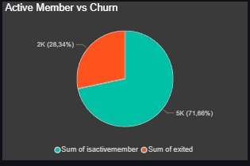
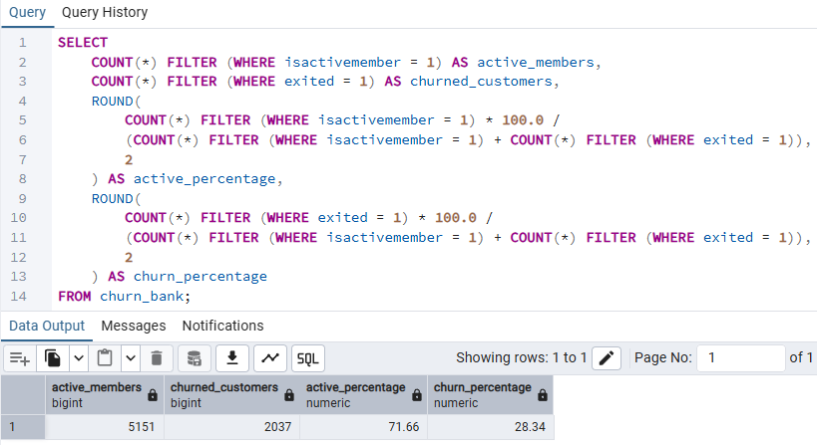

6) CHURN RATE BY NUMBER OF PRODUCTS : SQL RESULTS MATCHED POWERBI DASHBOARD ✅

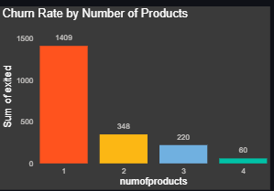
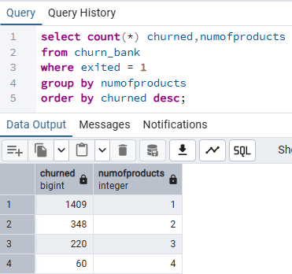
7)HIGH RISK CUSTOMERS BY GEOGRAPHY : SQL RESULTS MATCHED POWERBI DASHBOARD ✅
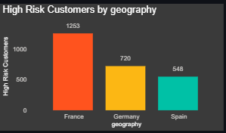
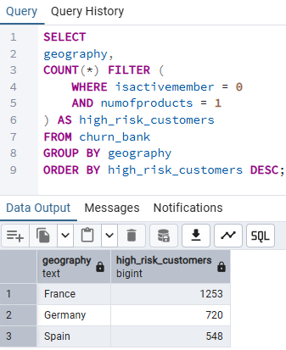

8) CHURN DISTRIBUTION BY ACCOUNT BALANCE : SQL RESLTS MATCHED POWERBI DASHBOARD ✅
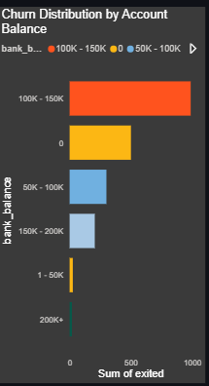

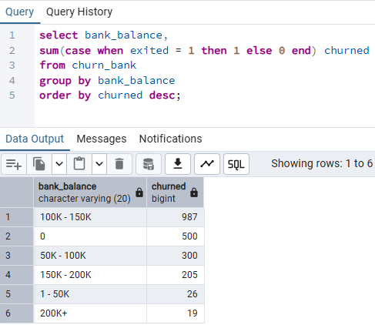

9) CREDIT SCORE IMPACT ON CHURN : SQL RESULTS MATCHED POWERBI DASHBOARD ✅
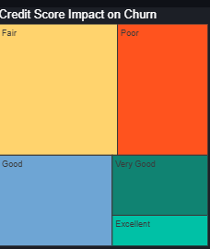
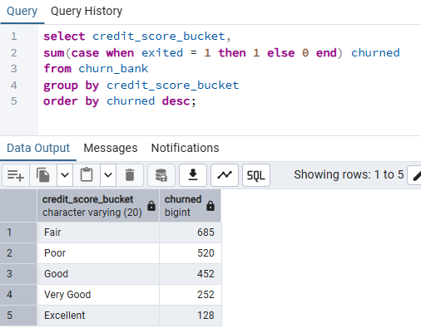
10) CHURN RATE BY GEOGRAPHY : SQL RESULTS MATCHED POWER BI DASHBOARD ✅
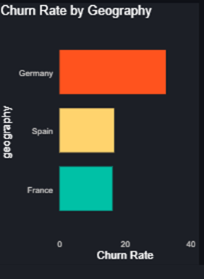
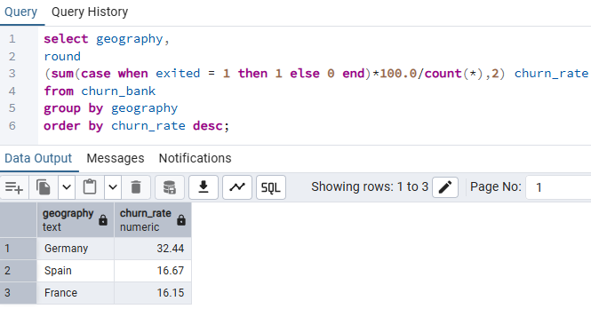
11) CHURN RATE BY CREDIT CARD HOLDERS : SQL RESULT MATCHED POWERBI DASHBOARD ✅

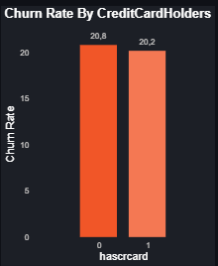
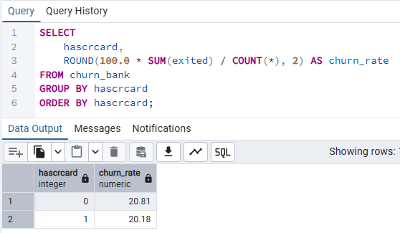
12) CHURN RATE BY AGE GROUP : SQL RESULTS MATCHED POWERBI DASHBOARD ✅
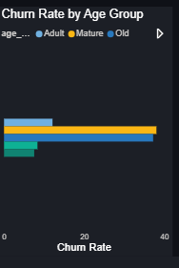

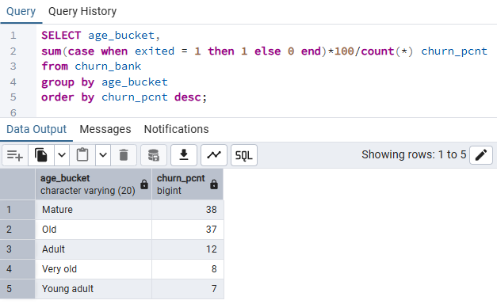

Conclusion:
All KPIs on the Power BI dashboard matched the results generated from SQL queries. This validates the accuracy, integrity, and dependability of the dashboard for business insights and decision-making.

